Steps for EF Database First Approach

Create db .

create database Ef_DB_First_Demo

use Ef_DB_First_Demo

create table Employee

(

Empid int primary key identity(11,1),

Name varchar(50),

Gender varchar(50),

city varchar(50),

Salary bigint)

insert into Employee values ('Vishal','Male','prayagraj',45000)

insert into Employee values ('Manak','Male','Ghaziabhad',45000)

insert into Employee values ('Ashi','Female','Noida',45000)

insert into Employee values ('Ansh','Male','faridabad',45000)

insert into Employee values ('Ankit','Male','Lucknow',45000)

insert into Employee values ('Rakshit','Male','Mumbai',45000)

insert into Employee values ('saurabh','Male','Mumbai',45000)

select * from Employee

open visual studio

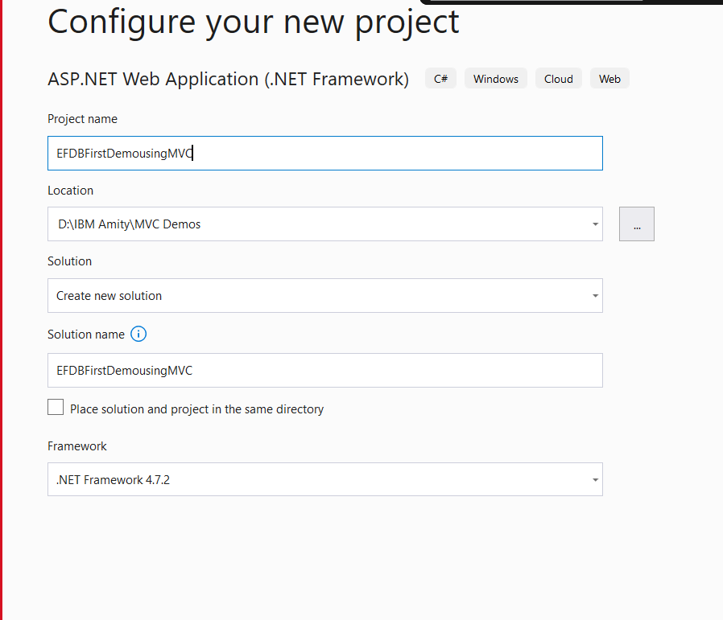

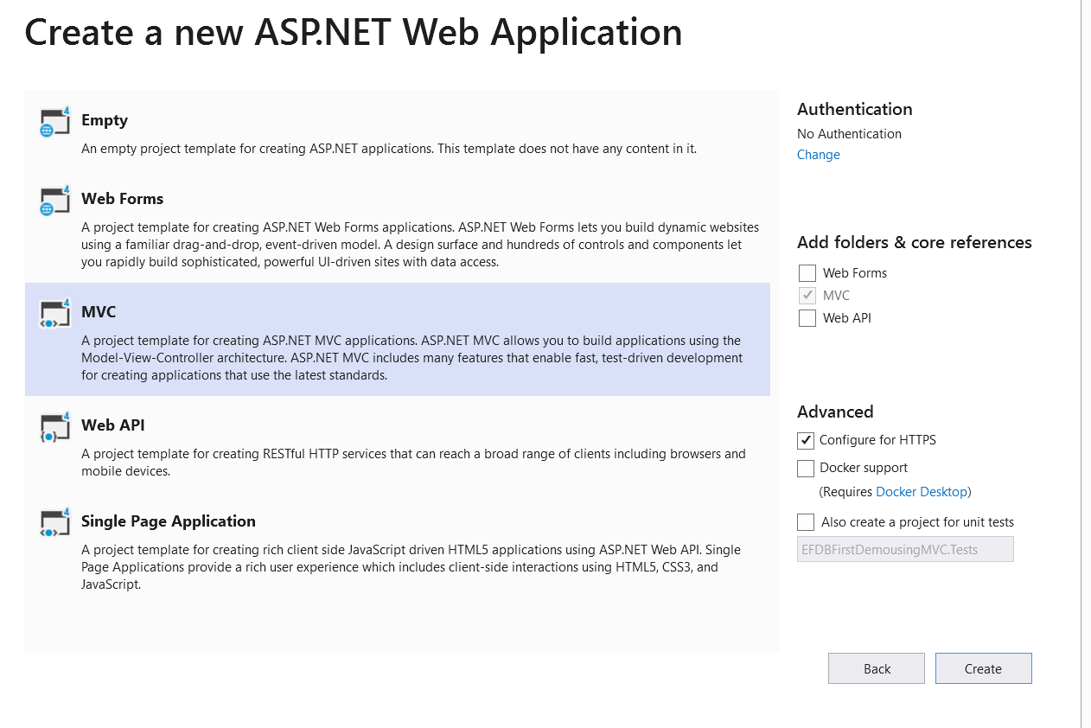

In Solution Explorer Right click on models Folder

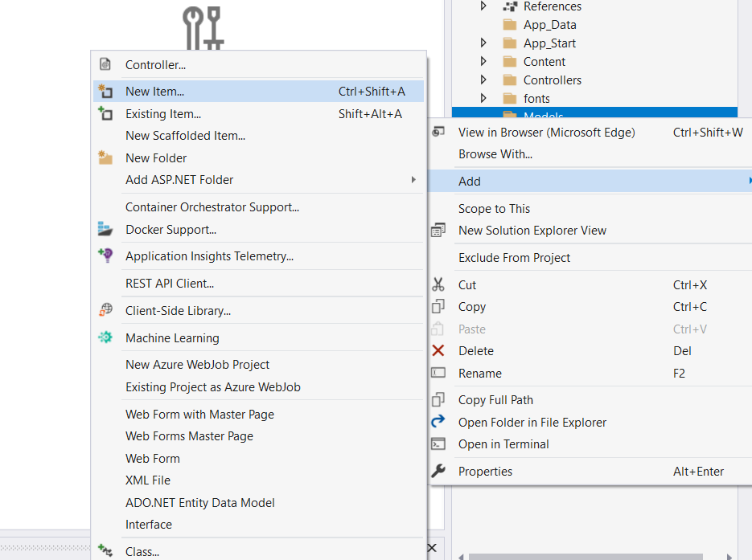

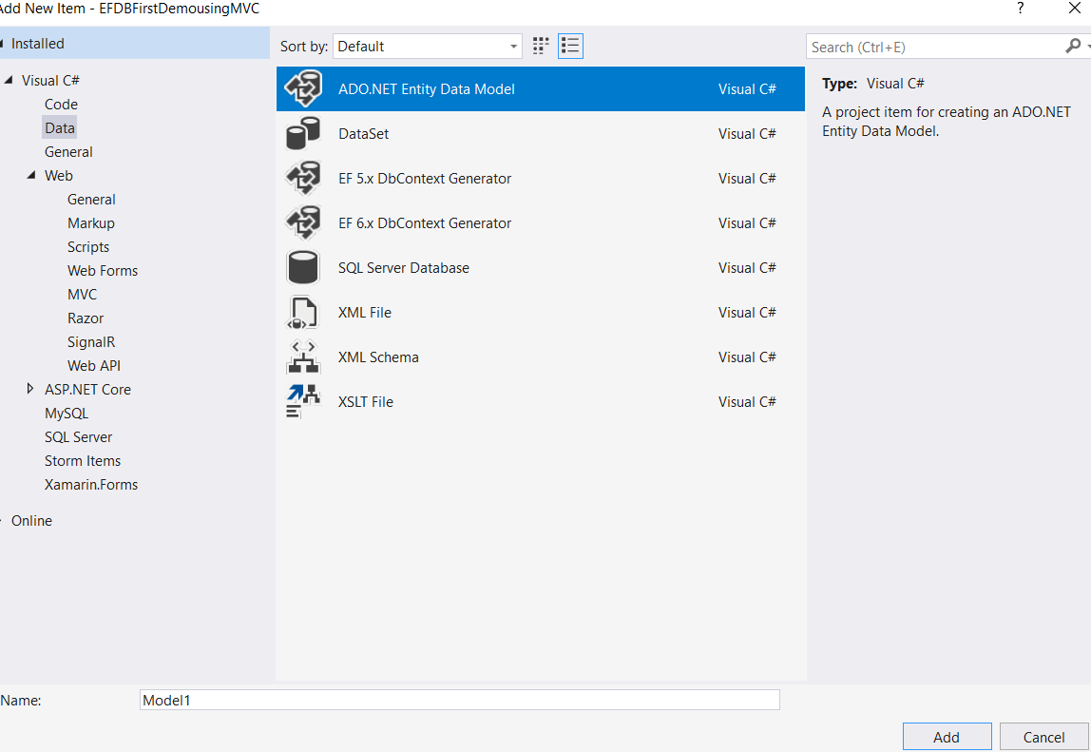

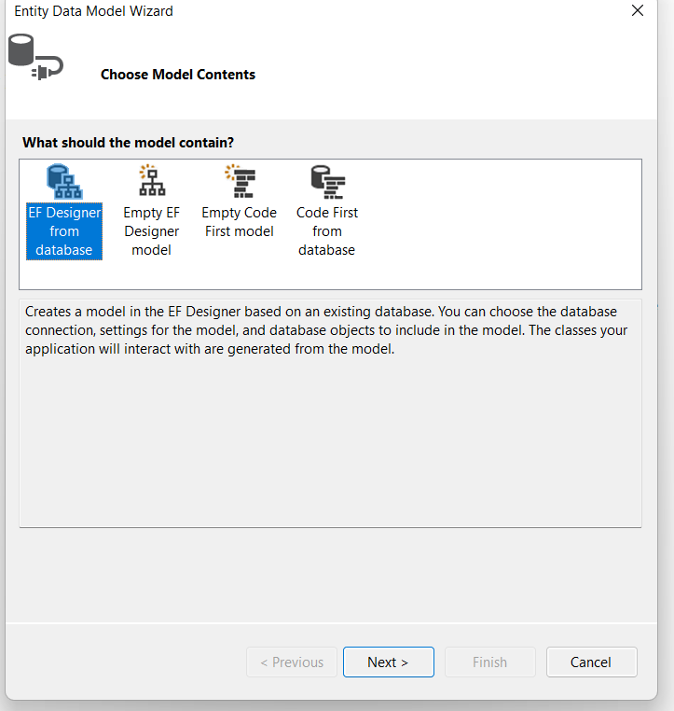

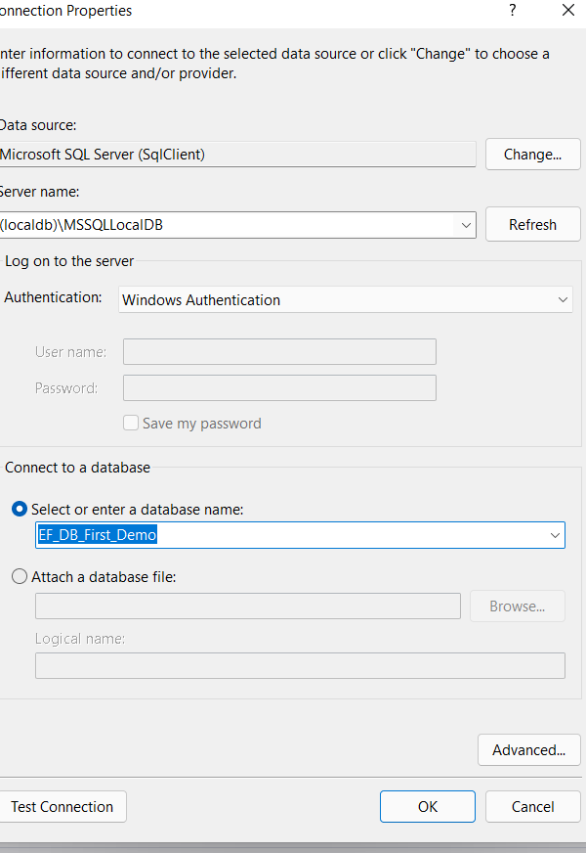

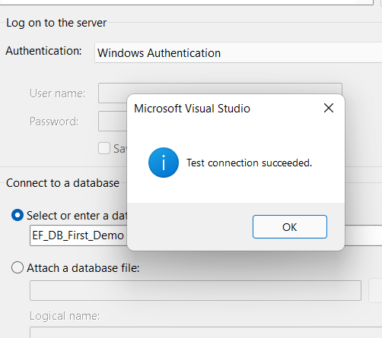

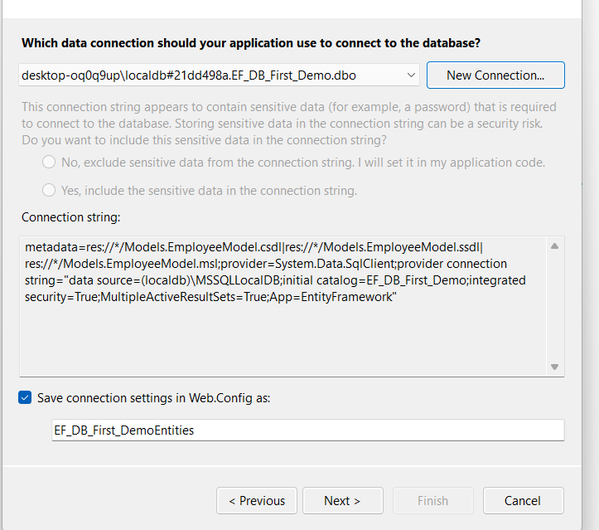

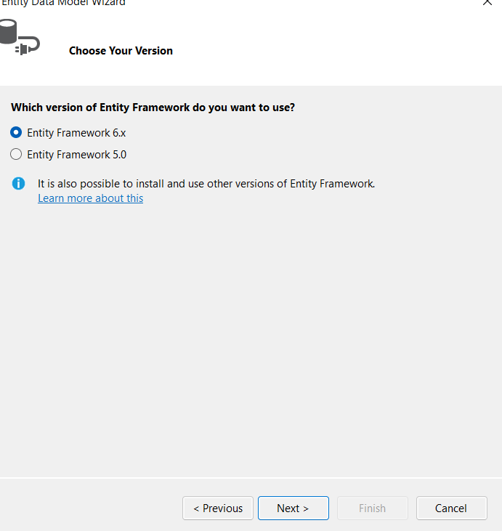

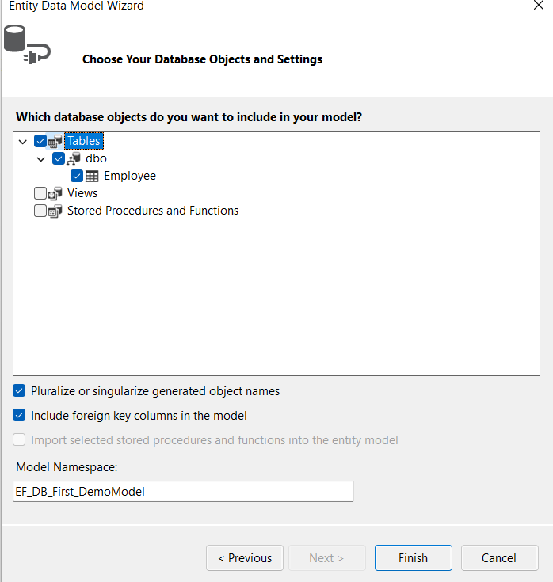

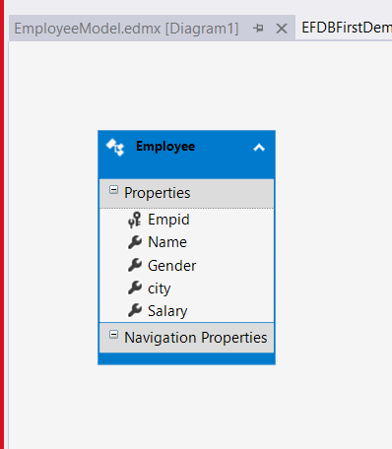

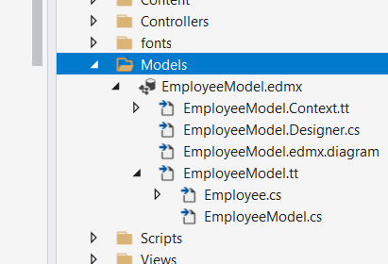

Build your solution

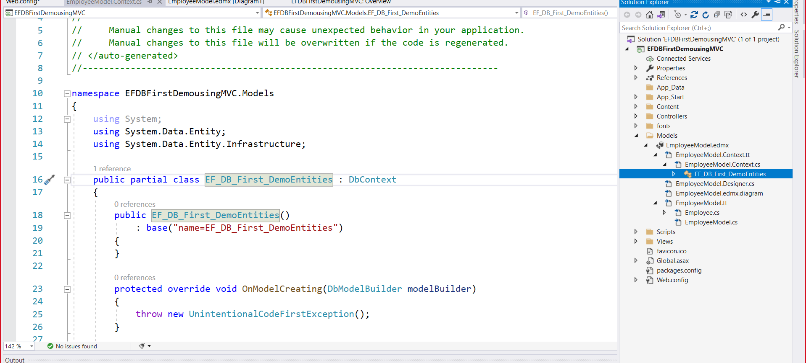

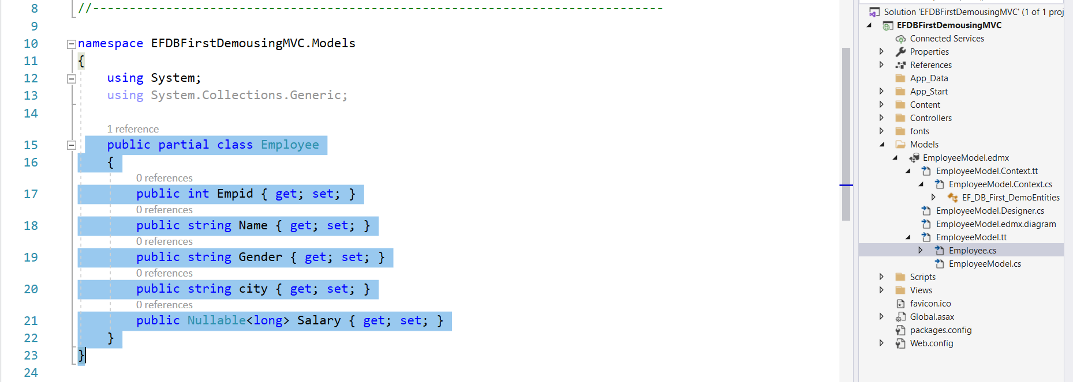

Right click on Controllers Folder in solution Explorer

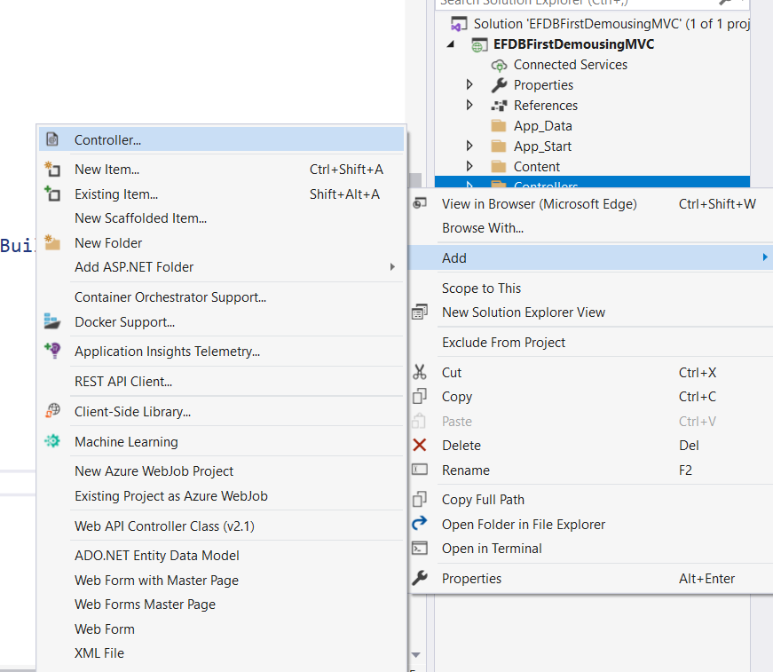

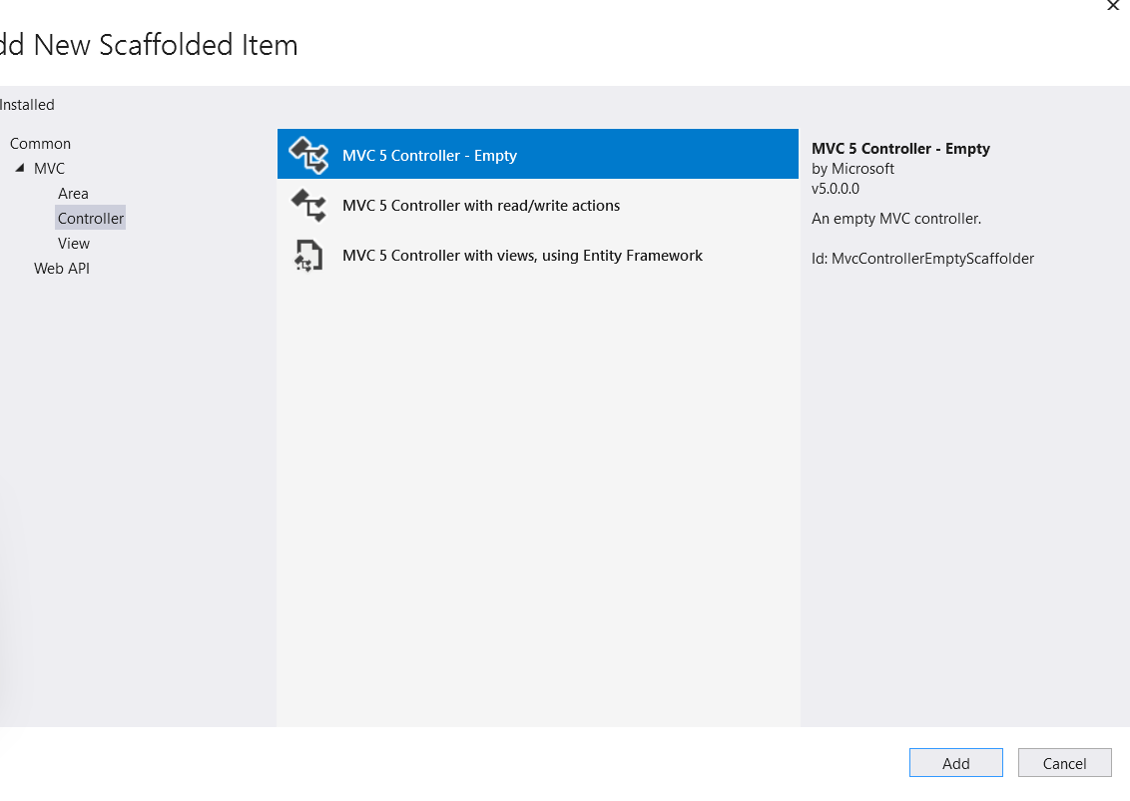

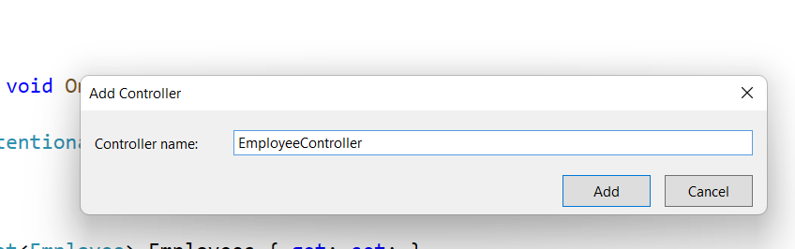

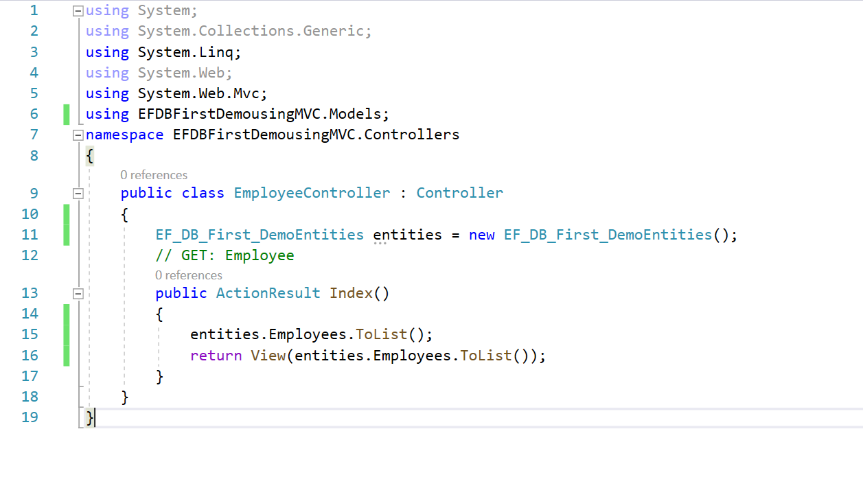

using System;

using System.Collections.Generic;

using System.Linq;

using System.Web;

using System.Web.Mvc;

using EFDBFirstDemousingMVC.Models;

namespace EFDBFirstDemousingMVC.Controllers

{

public class EmployeeController : Controller

{

EF_DB_First_DemoEntities entities = new EF_DB_First_DemoEntities();

// GET: Employee

public ActionResult Index()

{

entities.Employees.ToList();

return View(entities.Employees.ToList());

}

}

}

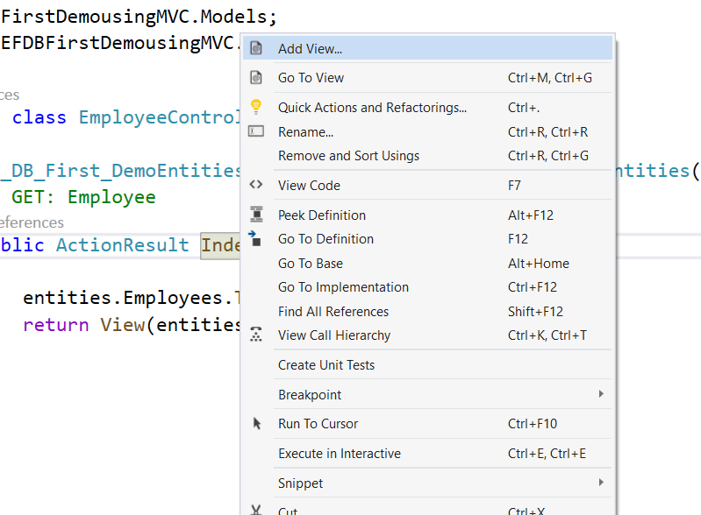

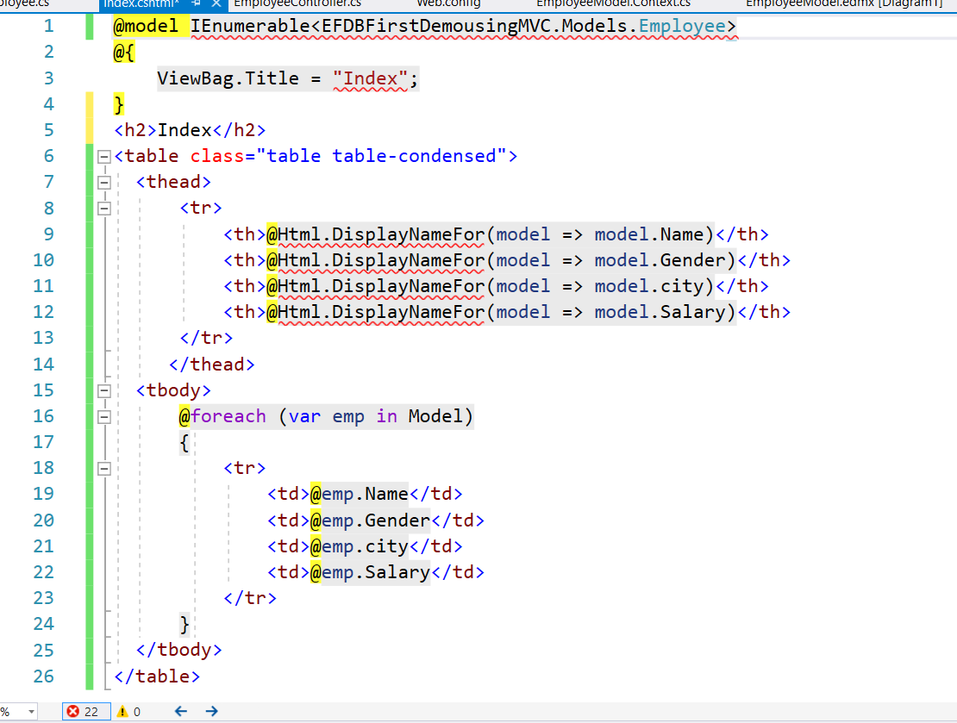

@model IEnumerable<EFDBFirstDemousingMVC.Models.Employee>

@{

ViewBag.Title = "Index";

}

<h2>Index</h2>

<table class="table table-condensed">

<thead>

<tr>

<th>@Html.DisplayNameFor(model => model.Name)</th>

<th>@Html.DisplayNameFor(model => model.Gender)</th>

<th>@Html.DisplayNameFor(model => model.city)</th>

<th>@Html.DisplayNameFor(model => model.Salary)</th>

</tr>

</thead>

<tbody>

@foreach (var emp in Model)

{

<tr>

<td>@emp.Name</td>

<td>@emp.Gender</td>

<td>@emp.city</td>

<td>@emp.Salary</td>

</tr>

}

</tbody>

</table>

Run your application:

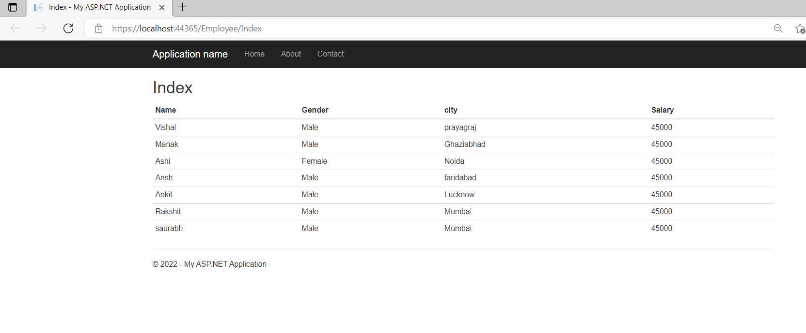

ActionLink Html Helper in the same demo

Add below method in EmployeeController

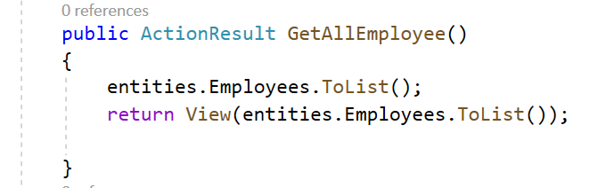

Add a view for the above method

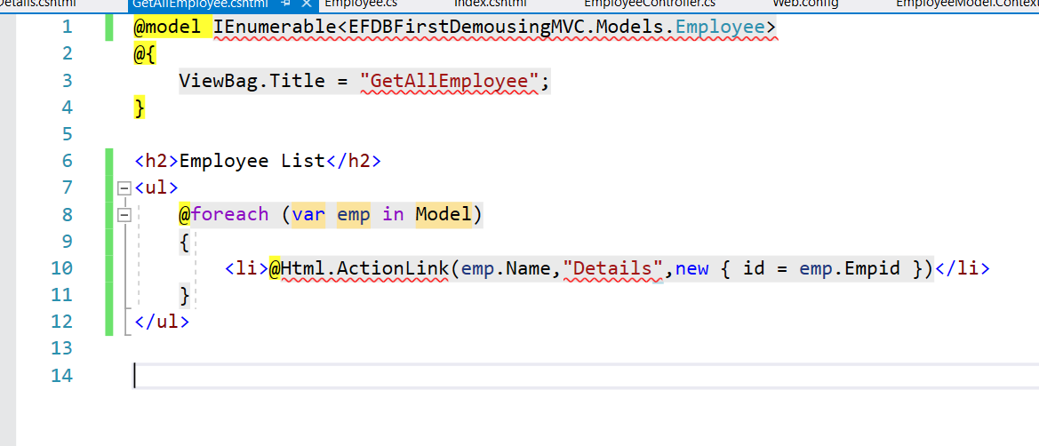

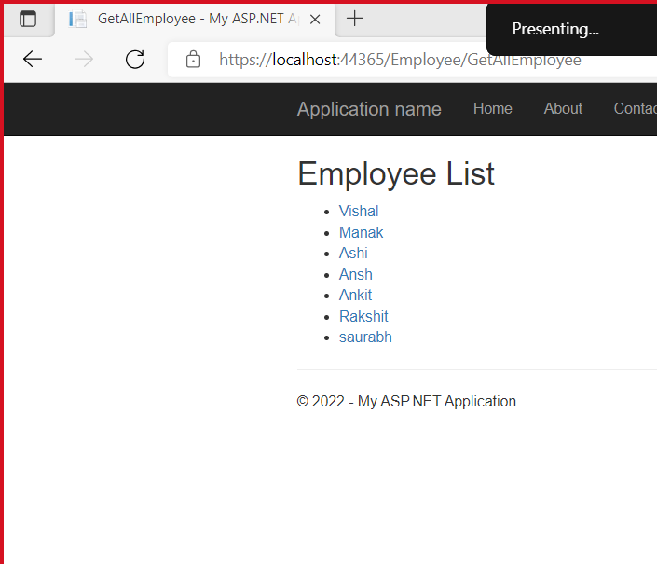

Add another method in Employee Controller

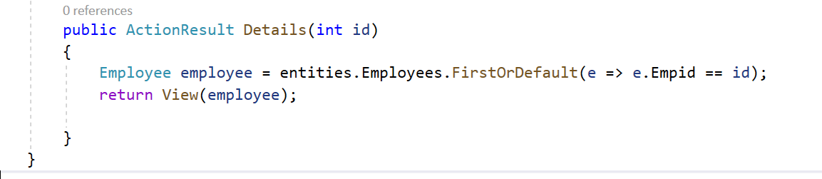

Add view for the above method

@model EFDBFirstDemousingMVC.Models.Employee

@{

ViewBag.Title = "Details";

}

<h2>Details</h2>

<div class="container">

<h3> Employee Details</h3>

<dl class="dl-horizontal">

<dt> @Html.DisplayNameFor(model => model.Name) </dt>

<dd> @Html.DisplayFor(model => model.Name) </dd>

<dt> @Html.DisplayNameFor(model => model.Gender) </dt>

<dd> @Html.DisplayFor(model => model.Gender) </dd>

<dt> @Html.DisplayNameFor(model => model.city) </dt>

<dd> @Html.DisplayFor(model => model.city) </dd>

<dt> @Html.DisplayNameFor(model => model.Salary) </dt>

<dd> @Html.DisplayFor(model => model.Salary) </dd>

</dl>

</div>

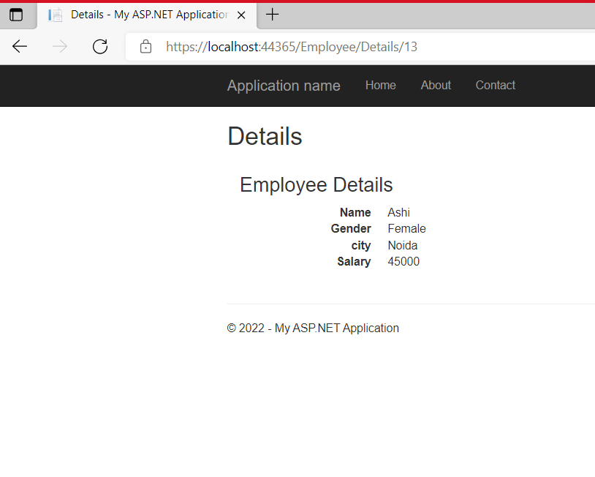

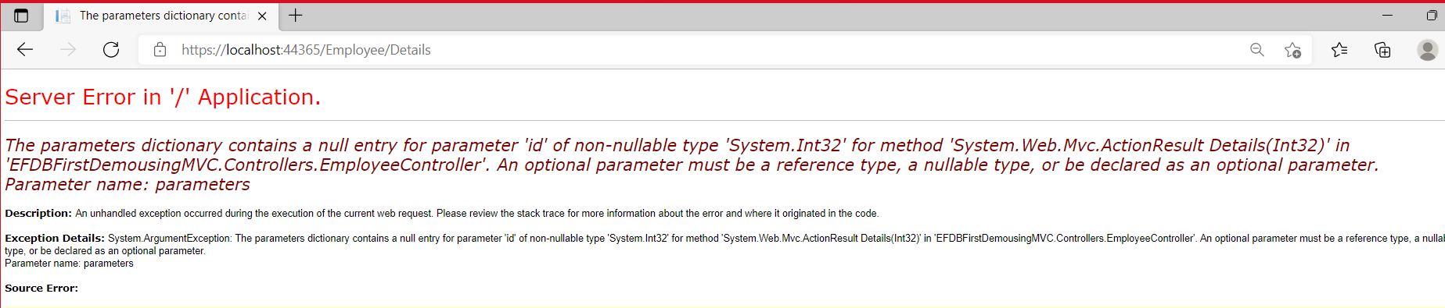

In the URL it is expecting id but we have not passed it so we got the above Error

Working with Multiple Tables:

Open SSMS Add another table.

create table Department

(

Id int primary key identity,

Name Varchar(50)

)

insert into Department values('IT'),

('HR'),

('PayRoll')

select * from Department

alter table Employee add DepartmentId int

foreign key (DepartmentId) references Department(Id)

Goto Models folder open .edmx file

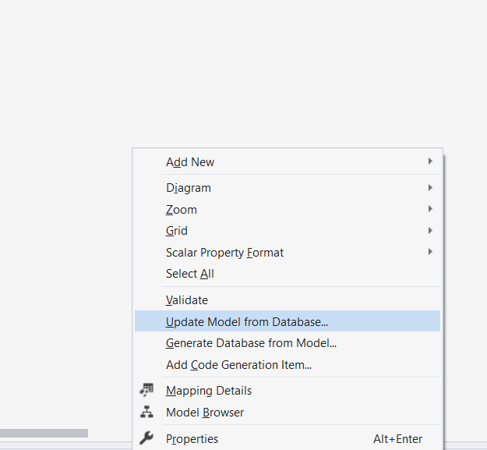

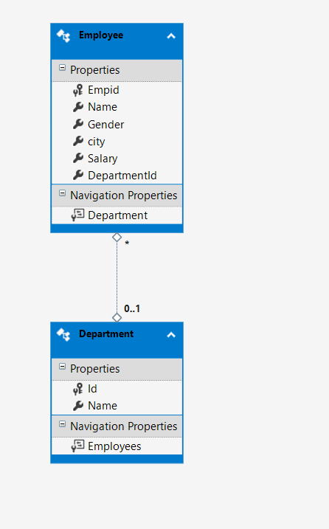

Build your Solution.

In context filr it will add Department class as well.

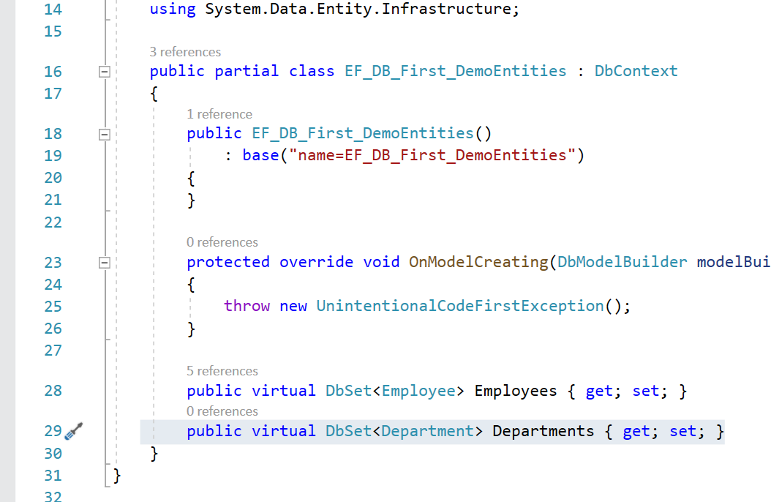

Add controller

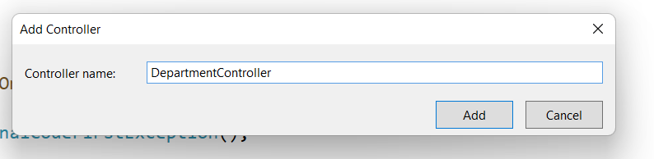

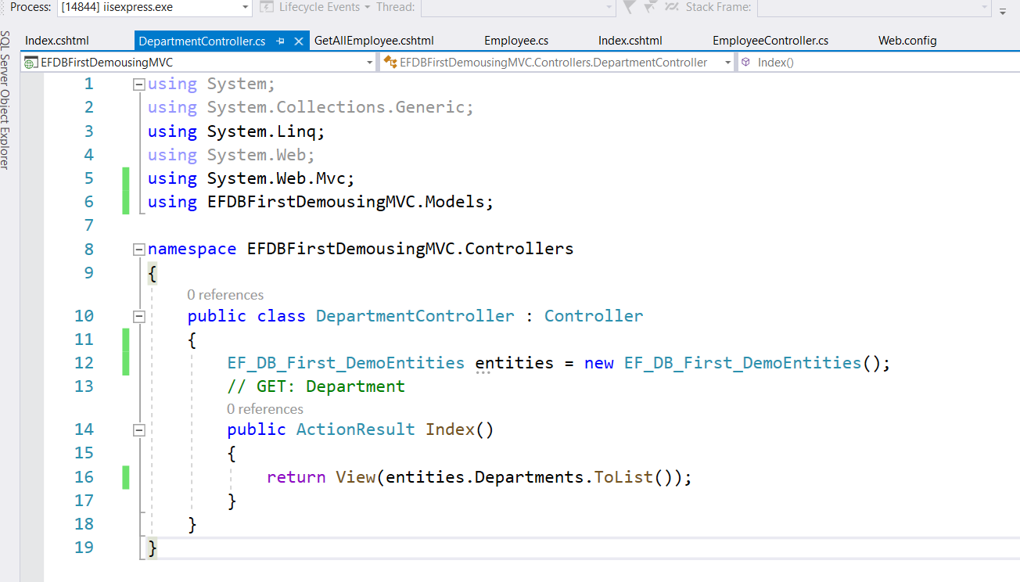

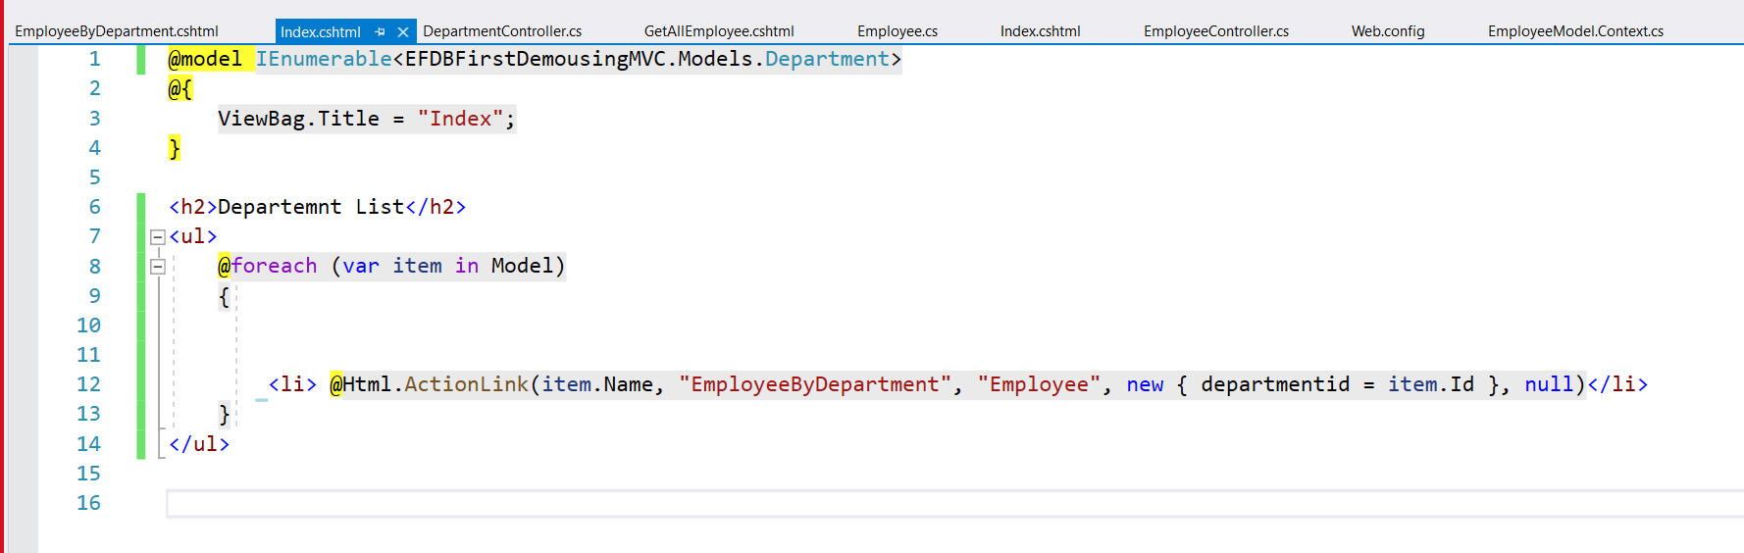

Goto employee controller and and below method and view for the same.

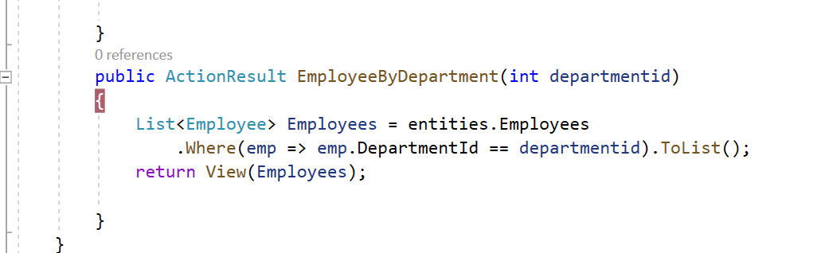

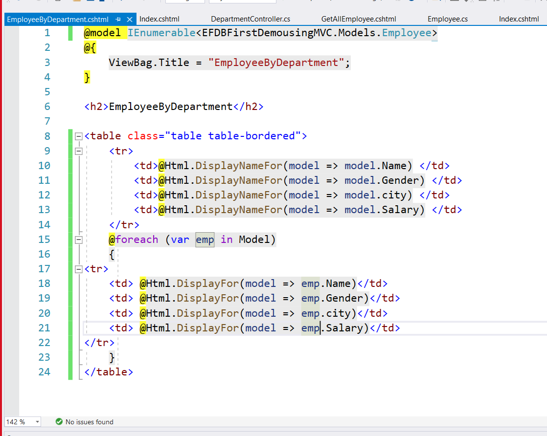

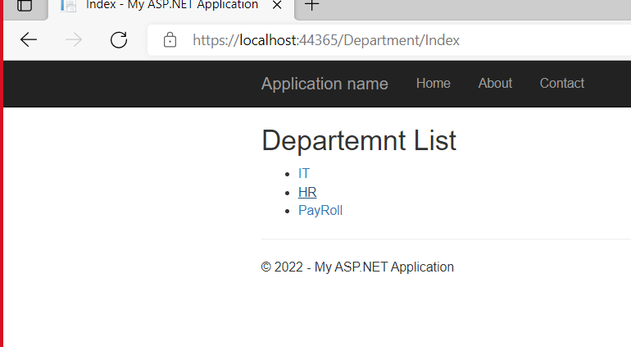

Click on HR link

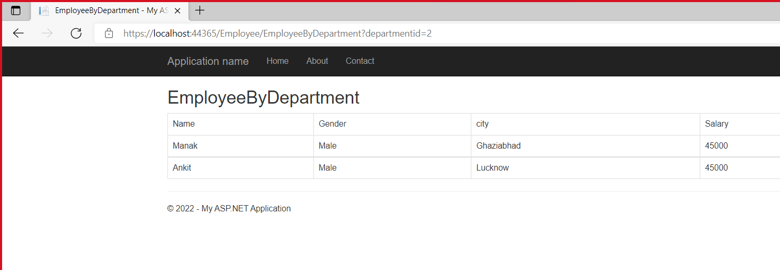

While clicking on IT

